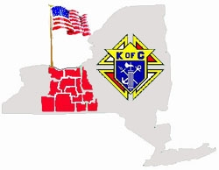 Finger Lakes Conference
You are invited to attend training

Kenneth F. Latham, State Deputy

The Essentials:
Council Officer Duties
Effective Leadership & Leadership Resources
Ceremonials & Forms
Grand Knight & Fraternal Planning Videos

Tuesday, May 8th, 2018
Registration & Subs 5:30-6:30 pm

Meeting 6:30-9:30 pm

Frank A. Cutri, Jr. Council
40 Gibson Street, Canandaigua, NY 14424
RSVP: Gary Stephany 585-461-5792 garys@rochester.rr.com
PLEASE RESPOND BY APRIL 25 WITH COUNT OF ATTENDEES TO ENSURE ENOUGH FOOD!

